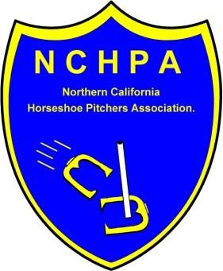 **2025 NCHPA DOUBLES CHAMPIONSHIP**

# Held in conjunction with the NCHPA Championships at the Stockton Courts

**Entry Fee $50.00 per team. Team Cap = 110% closing date September 17th. The 2025 NCHPA Doubles Championship Tournament will be held at the Stockton Horseshoe Club on October 5, 2025.**

**Pick your partner from any NCHPA, SCHPA, NEVADA Member. Send $50.00 per team plus completed entry form in by September 17th. Each team will pay the scorekeeper $2.00 per game ($1.00 per player). The cap on a team is 110% combined. (Example player A is 65% player B cannot be more 45%) These are Championships – No Handicapping. Groups will be formed based on the number of entries, with a minimum of two (2) groups. Prize money and awards in each group will depend on number of entries.**

**Send entry form and entry fee to Gail Sluys 1721 San Ramon Way Santa Rosa CA 95409. Phone 707-538-3128. Cell 707-486-0594**

**More information to follow as the tournament nears.**

**CUT HERE………………………………………………………………………….CUT HERE………..**

**Player A ________________________________%_______Charter________**

**Phone# ___________________ Email _____________________________**

**Player B _______________________________%________Charter________**

**Phone#__________ __________Email______________________________**

Entry Fee $50.00 per team **$__________________**

# C:\Users\Casey\Desktop\NCHPA Logo.jpgNCHPA CHAMPIONSHIPS Entry formC:\Users\Casey\Desktop\NCHPA Logo.jpg

**October4, 2025HOST CLUB – Stockton Horseshoe Club**

***PRIZE $$ & plates for your plaques***

***ENTRY DEADLINE must be POSTMARKED Sept. 17, 2025***

***Takes just one NCHPA sanctioned event to enter!***

**Participants must have pitched in (1) NCHPA sanctioned tournaments before September 17, 2025. New members who joined after August 1, 2025 need a minimum of** **one (*1)* NCHPA sanctioned tournament before September 17, 2025.**

**TOURNAMENT is open to all NCHPA members with an eShoe average ENTRY FEE $20.00 per adult pitcher**

**Mail Entries to: Gail Sluys *1721 San Ramon Way* Santa Rosa, CA. 95409**

**QUALIFICATIONS FOR THIS TOURNAMENT MUST BE MET. NO REFUNDS AFTER SCHEDULE IS COMPLETED.**

**-----------------------CUT HERE------------------------------------------ ---------CUT HERE-----------------------------------------**

**Mail this half or copy and email it.**

**Name: E-Mail Address: _____**

**Address____________________________________________________________________________________**

**City____________________________________________________________**

**NHPA CARD # Birth Date: ___**

**Phone #______________________________________**

***Please circle the Group you are entering.***

**OPEN MEN OPEN WOMEN ELDERS 65+ JUNIOR GIRL/BOY (free) CADET 12 & UNDER (free)**

**SR.MEN SR.WOMEN**

**\*SENIOR GROUPS NOT HAVING A MINIMUM OF 6 PLAYERS WILL BE MIXED WITH OPEN CLASSES.**

**ENTRY FEE $20.00 $ __________**